**Conversation Guide: Digital Health Modernization Discovery Research - Caregiver Group**

**Bold text identify the moderator’s questions.**

*Text in italics are Jen’s observations and interpretations of the participant.*

[Text in brackets are interpretations in participants’ direct quote.]

**Background (5 minutes)**

To get started, I’d like to get a little background information about you, and your experience with the VA.

*Note that this was a caregiver interview but the Participant was actually a Veteran.*

1. **Can you tell me a little bit about yourself?**

I got out of the military in November of 2011. I think it was a Friday, and so I transitioned to the VA on that following Monday.

I deployed 6 times and was in the middle of some health care.

So from 2011 to 2017, I think was the last time I went to the VA

Some were surgeries. Some dental stuff that didn’t get fixed. I had one shoulder, two foot surgeries, and then I had a crown [Participant points to mouth] that the VA finished.

I had primary care for those years then I finished the issues with my foot in January of 2017. I haven’t had any issues since with my service connected injury so I haven’t had to go back since but I know I can if I need to.

1. **Left in 2011:**

Yes.

**Which branch did you serve:**

Army for 8 years.

**Where are you located:**

DC. Originally I was living in Maryland so I went to the Baltimore VA until 2015. And then when I moved I switched to the DC VA. First surgery in 2012 at the Baltimore VA then the foot surgery and primary care at DC after 2015.

1. **What other VA benefits do you receive?**

Dental care.

I am using my GI bill now. I used part when I first got out. I have 19 months now and started this last fall for another masters program.

I have used the VA home loan for several homes as well.

I think that is all of the benefits I have used over the years.

**Process of transitioning:**

I think I got out on November 21st, 2011. I had come back from Afghanistan, which was my 6th deployment, in July. Between July and November I was on terminal. I had issues with my shoulders and feet I was starting to address. It took a while. No one gave it much attention at first.

I finally got the outcomes of my shoulder at the time, when I was still on active duty terminal leave they did and MRI and said it was torn and I needed surgery. But I didn’t have time to schedule the surgery before I got out.

Again then dental, came back in July [from deployment], they started to fix a crown and didn’t finish it before I got out.

Those were the issues I needed. It took a while for all that stuff.

I had my records and did all the filings I need to do and took that to the VA to register that Monday.

I don’t know if I got lucky but the Baltimore VA, I provided my information and he saw all the deployments and sent me to the Combat Advocate.

Thankfully I met this Combat Advocate and he is the best person I have dealt with at the VA. He made it so easy, they were understanding. He set up all of my appointments for orthopedics, dental, and primary. He was as saving grace. Then when I had issues they helped me or tell me what to do. So between 2011 and 2015 I dealt with him. Then they transferred me to DC.

It was a lot. Like the surgery, getting the appointments. I got in and finally it took a while. They had me talk to different people, the individual the looked at the MRI said it needed fixing. That was in December and I didn’t have surgery until May and that was me having to go to the administrators of the VA.

The orthopedic side was really crazy busy backed up. I didn’t have follow up and appointment. I didn’t have physical therapy scheduled. I had to go down there and stand for hours so I could get seen so my care didn’t get delayed.

I think over the years, 2011, 2012, 2013 it got better. But 2011 it seemed like was the height of the height and it was hard to get care. And I wasn’t working so I was going every day to see if they had any cancellations or a date yet.

The dental wasn’t as bad. I had my records and they got me scheduled two appointments.

But orthopedics was a mess. So in Baltimore I had my shoulder surgery there and rehab there.

Then I saw a podiatrists because I had an issue with my foot. But I waited until I got to DC to do the foot surgery. That is another horror story.

The first podiatrists said it was something else and that I couldn’t walk on it because I broke whatever.

I knew that wasn’t right so I talked to someone else and it was put on hold until they got a new podiatrist. So 6 months later he looked at it and he knew what to do. He is a contractor doctor though. He scheduled the surgery and was interested in the care and follow up. They had to take 3 inches out of my tendon. And I was in rehab for a year.

So once I got to that second doctor, after the nonsense with the first podiatrist, he made sure along with the physical therapist to follow up because it was such a long recovery.

So 2015 2016 there were still issues so by then they had a new podiatrists and he said the hardware needed to come out. So in January of 2017 I had the third surgery to get it out.

So since then I have been between my foot and shoulder.

**Were all those surgeries were from VA:**

Yes.

I did have a right shoulder surgery that was service connected but I used my private insurance because I didn’t want to go back. I was dealing with foot in DC and I didn’t want also add in that surgery.

That was 2014, I did the first one [shoulder surgery] in 2012, then the second one on my own. And then my last big foot surgery in 2015. So I did one on my own who because it was already enough so I used my private insurance. And it [surgery] wasn’t that bad, they just went in to clean it up. I decided to not do that one through the VA because of all the other stuff I was dealing with them.

**You used private insurance. Was that through employer**:

Employer.

**Going back to when you were enrolling in the VA and working with the Combat Advocate. Sounds like you were doing a lot of in person activities :**

I’m a lawyer, I was in the Army JAG. It takes a lot of fortitude to be injured and get care. I always wonder how it would be for those that didn’t have the experience I had, to be so demanding. It was really frustrating.

There was one time, I think it was 2011, I saw my primary care provider for some allergies and she basically told me to just stay inside. So I went back to my Combat Advocate, and I was upset because I am already dealing with so much. And I just want relief for the symptom and they gave me another primary care provider.

It was a hot mess back then.

1. **Were you using any other tools or resources online?**

Online wasn’t a thing back then. It wasn’t until I switched to the VA in DC. They had the kiosk where you can register but Baltimore didn’t have that.

The other primary care provider was fine, she helped me with my allergies.

When I switched to DC the primary care provider I got there, she certified the referrals I needed for orthopedics and podiatry. But there was a certain point in time where she wouldn’t see me again until I went to behavioral health. I was screened for PTSD and all those things, and I didn’t have any of those issues. So I stopped seeing her. I am not going to behavioral health to get primary care if I am having to deal with this major foot issue.

I had to do the post deployment counseling to get out of the military. When I to the VA with the Combat Advocate they did screenings, and when I switched to DC they did all the screenings again. And so I stopped seeing her because I am not going through behavior health just so you can check the box just to get primary care.

So then I started using my private insurance for primary care.

**That is what tipped the scales to use private insurance:**

Yeah. That was when I was dealing with my foot issues with the new doctor.

**All your health care you use your employer based insurance now:**

Yes it is routine stuff. I do a physical each year and then allergies.

**Experience of navigating two health care system, VA vs private:**

Private insurance is easy. They want the insurance money so they give you an appointment.

I don’t want to blame the VA because they have done a lot of work. Between 2011 and 2015, starting in Baltimore and switching to DC, I didn’t have to show up in person as much to get appointments. I could call and get an appointment it might could be a month or two away for an appointment.

Baltimore you might sit on hold forever, or they would say they would call back but then they wouldn’t. So there was a difference between the two. It may have been timing or the organization or management but it was really hard at first.

We were all deploying in 2008-2011.

The other thing to the primary care wanted me to go to behavior health because she said it would be helpful to speak with other veterans. The funny part about that when the Combat Advocate, I guess then they were bringing in more providers, so the advocate and their supervisors would have me talk to the new providers to the VA. Because this is what a 6 time combat vet looks like.

They had me do a career fair, a commercial, and a radio show. So they can bring in the non-traditional veterans, because it wasn’t as diversified back then so I guess they wanted everyone to feel comfortable. So I did that and spoke in two conferences.

One of the people that worked with the advocate was a social worker show trained the providers and so I spoke at a conference he was doing, like and this is what a combat veterans look like now. I was a lawyer at the time for 8 years, and was deployed 6 times. So the challenges I was facing were just different then it used to be.

It was at Salisbury State and a Baltimore conference to new providers about the challenges I had and to share my experiences with transitioning.

So when I went to DC and my primary care provider wanted me to go to behavioral health, it wasn’t like I hadn’t dealt with my issues. I was speaking and working with my own advocate, that was how I re-assimilated after 6 deployments in 8 years.

**It sounds like you had a really unique position and a great perspective to share:**

I don’t know if they still have the Combat Advocates but that’s was the only way I got through those initial years. A specialized person because it is on my record, they me go to the office, to help me. They were specialized and they had different avenues to get me care because of my deployments. It was different than someone who stayed state side.

I deployed to Afghanistan, Iraq, Africa, and Korea. But for that I don’t know if I would assimilated as well if it weren’t there.

So you if don’t have that [Combat Advocates] now, get it keep it. It is different when you deployed that much.

**Recent online VA tools:**

Not for the health care. I would call for my follow up and physical therapy.

For my VA home loan and GI bill stuff is online now.

When I first used the GI bill online in 2011 you had to call each semester and would be on hold for hours. So when I started getting into using the rest of this year it was totally different. I actually called to make sure I didn’t miss anything.

Now the school rectifies it and I don’t have to do anything. They took care of it, they walked me through how it works and it is all online so it is a ton easier now.

Even certifying the school, getting my certificate of eligibility.

It was the same thing with home loans. Back in 2006 you had to go to an office and get a piece of paper. When I used it in 2015 here in DC it was all online.

I haven’t used the health care online.

**For those other services do you recall which website you used do you do that?**

Va.gov then there is a GI bill section and a home loan section.

With my home loan I think my loan officer or realtor walked me through and initiated it.

For the GI Bill stuff I was able to search an find what the benefits were. And too how to get my eligibility certificate for the school online and then they just send it to the school.

**Healthcare through your private insurance. Do you use any online tools to manage that:**

Yes, I like just scheduled my physical in January. I tried to do it online, but they told me to call. So I called then they called me. I get my lab results and physicals online or she will call.

**Other features in online tool you like:**

My health insurance is Aetna and they have telehealth. So if I just need to, like I think I had a rash once, I just go into my log in to my health insurance website and go through their link to request a video chat with a teledoc. I have done that once.

I have also, the thing I used most with my health insurance since its an HMO is search for providers. My dermatologist changed practices so I searched for him by name to see if he is at another practice now. I can search to see who is in network for the benefits. I think that is what I use most online for my private health insurance.

**When you had shoulder surgery you used your private insurance. So you weren’t billing the VA:**

Back then you couldn’t do that. Now I understand you can. I get the flyers and emails from the VA that you can go to your provider of choice. Back then you had to stay in the VA system.

For the orthopedic doctor I had for shoulder surgery at the VA in Baltimore, he was actually from the University fo Maryland health care system but he volunteered once a month at the VA. Thats who I saw when I had issues with follow-ups, and that was the complication because he only worked there once a month. So that is how I had issues with my follow-up to be cleared for physical therapy. Somehow I called his non-VA office and told him the trouble I was having. So he did something where I could see him at his private office and the VA paid for it. That’s where I got the clearance to be able to get physical therapy because the VA just wasn’t getting me an appointment with him.

Back then you couldn’t do that but now I know people go other places outside of the actual VA system.

**Do you remember the process for getting your health record from the VA to the outside surgeon:**

He had it from the VA.

When I left active duty, to do the disability filing there was a person you went to and they helped you file it all. You get this list of people to see to out-process, and she was one of them. She told me how to get a copy of my medical records and once I got that she made two copies. One she sent to the VA, and one gave one to me.

That’s how that happened so that Monday my record was in the VA system for my deployments, there wasn’t really an issue but I had a backup. *Participant seems to have thought the question was how did the VA medical system get her health records.*

After that when I started not having much care I got the updated part from the VA just so I have a copy.

**How did you get that update record:**

Old school. Go in fill out the form and hopefully you get it in a couple months in the mail. I think I chose to pick it up.

1. **Do you use any mobile apps to manage your health?**

No, when I go on my private insurance I go on the website so I can see all the, like last when I was looking for a doctor I can see all the addresses and make sure it is what I am looking for.

If I go on teledoc app through my insurance. I guess my profile is saved in there so I could use that. That would be easier to do it on your phone instead of looking at the laptop waiting for someone to pop up.

**Mental model of health at the VA (20 minutes)**

Now I’d like to hear about your experience first learning about VA benefits. **(10 minutes)**

1. **How would you explain a “disability rating” to a new Veteran?**

Basically it is the percentage that equates to the injuries I have that and I receive a monthly check for it.

To be honest, when I got out the only thing claimed was I had issues with my eyes. I had IT syndrome in my legs, and my first foot surgery. I was 40 percent connected. I never went back to update it for the other surgeries. I am just not ready to deal with. Everyone gets on me for doing that. I just haven’t done it, I probably should because I am service connected so I can get care but I haven’t updated my disability rating to be compensated for it.

Everyone says to do it. They say it is better now.

**That sounds like a big hurdle to overcome:**

I mean that was 2011, 2013 and I am still emotional about it. Maybe next year. 2020 is not the year to do that. *Participant is visually emotional and crying.*

1. **In your mind, is there a relationship between "disability" and "health care"?**

I think I did originally I did but then the Combat Advocate explained it to me. I needed the service connected notation on my file.

Honestly for me everything I had to do to continue the care is in recognition of what I sustained. I can do pushups like I used to do because of my shoulders, or run like I used to because of my foot.

So to me it is a recognition to have to endure all that. Which is why I haven’t gone back to do more.

I think originally I thought the disability rating, I think sometimes the amount you had or how you were classified mattered. Like there were priority levels. The combat advocate told me that if you are service connected and a combat veteran than it helped you have a higher priority. Didn’t matter I still had to fight for appointments.

My biggest foot surgery was in August 2015 and went through rehab until August 2016. But there was still little pain but there was no issue to figure it out it was the hardware that needed to come out. And they scheduled it within like a month, so that was the end of 2016. So that was a way different experience.

I could tell over the years it got better. It wasn’t as hard as 2011, 2012.

They started to get the kiosk to get checked in instead of waiting in line. With the one lady with 10 people on your crutches. The kiosks helped. *Participant laughs.*

1. **When it comes to your health, what is the most important thing you needed from the VA?**

I just needed stuff to be fixed. I had the issues with my shoulder, foot, and the crown that wasn’t permanent fixed. I was entitled to and didn’t have any where else to go because I didn’t have a job. I was using my GI bill for school and that is the only option I had.

1. **I know you weren’t using any online tools. Wondering if I can show you something on my screen:**

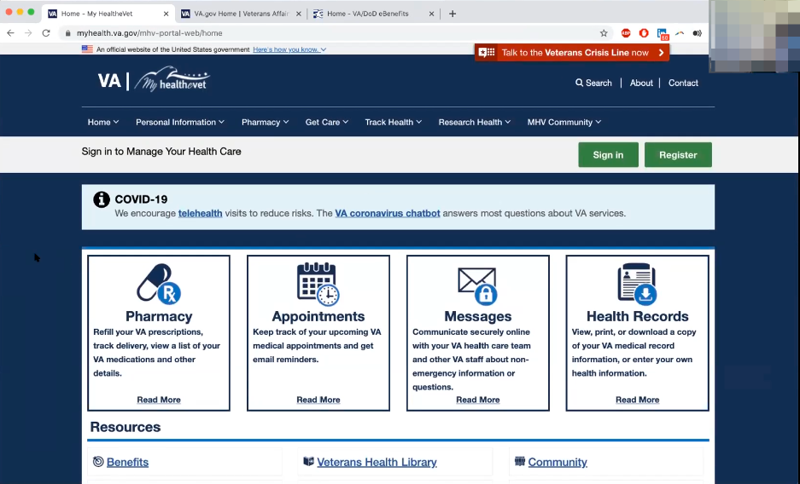

Moderator shares screen and shows My HealtheVet home page.

My HealtheVet. *Participant immediately recognizes and calls site by name.*

When I came to DC the new advocate got me, I have it right here, this is my card. *Participant holds up an id/info card with My HealtheVet logo and information.*

He registered me and got me this card. So that would have been 2015/2016. He got it so I could renew my prescriptions I had at the time.

I don’t think I did appointments but I did prescriptions and I could go pick them up. Because they weren’t delivering them I had to pick them up.

I do remember using the prescription part of that, but I don’t have my account.

**When do you think the last time you used it was:**

Probably 2017.

Is it only for healthcare? I think you can go through here to get to the GI bill stuff.

**Do you want to try to do that:**



Participant shares screen. Hand types in my [health.va.gov](http://health.va.gov) into Chrome address bar. Got address from My HealtheVet id/info card they were given.



Participant gets “Request URL was rejected” error message.



Participant hand types [www.myhealth.va.go](http://www.myhealth.va.go)v in Chrome address bar

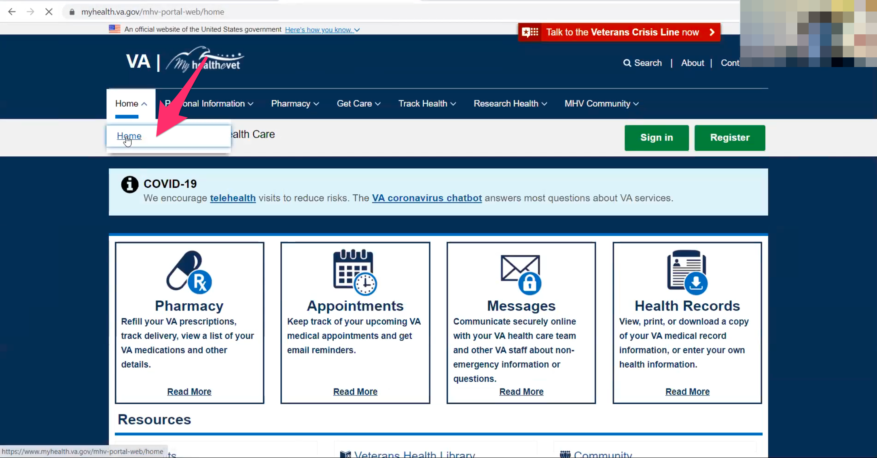

My HealtheVet home page loads. Participant immediately clicks on “Home” in main navigation and then “Home” in the sub menu drop down.

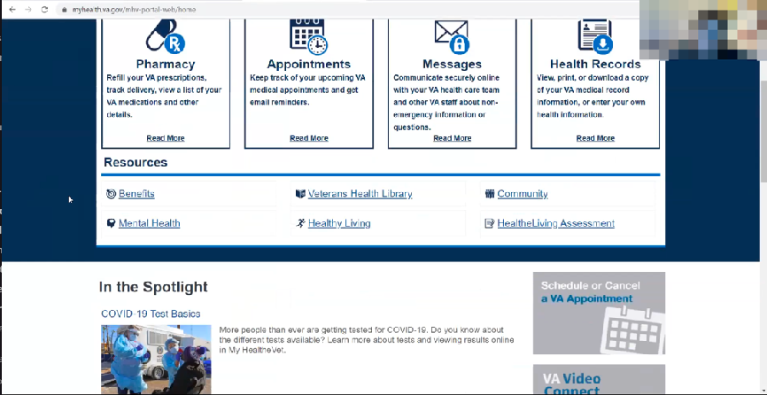

My HealtheVet home page reloads. Participant immediately scrolls down.

Hmm. Maybe it’s here.

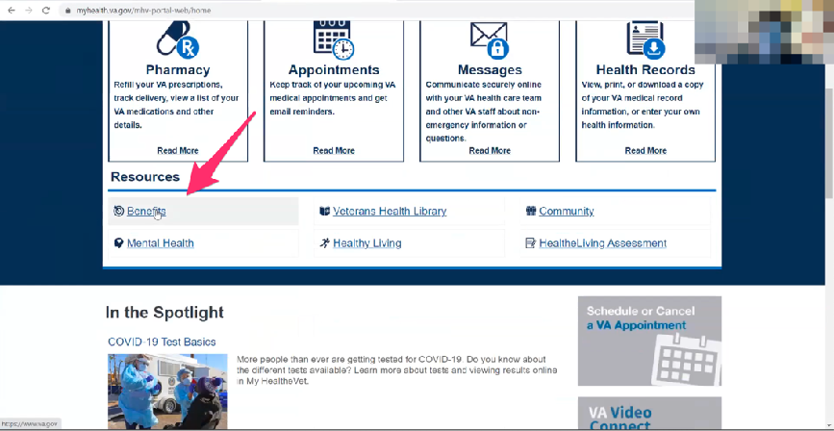

Participant clicks on “Benefits” link in Resources section of My HealtheVet home page.

Yes. So you back to main VA. I log in here.

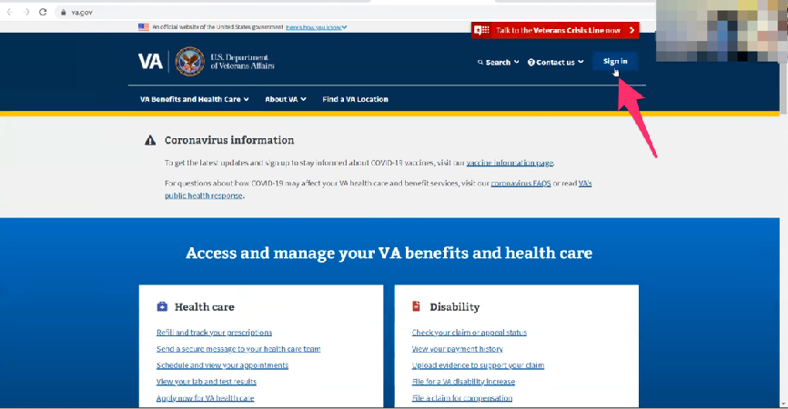

[VA.gov](http://VA.gov) home page loads in new tab. Participant hovers over blue “Sign in” link upper right of page.

And the education is here. VA.gov.

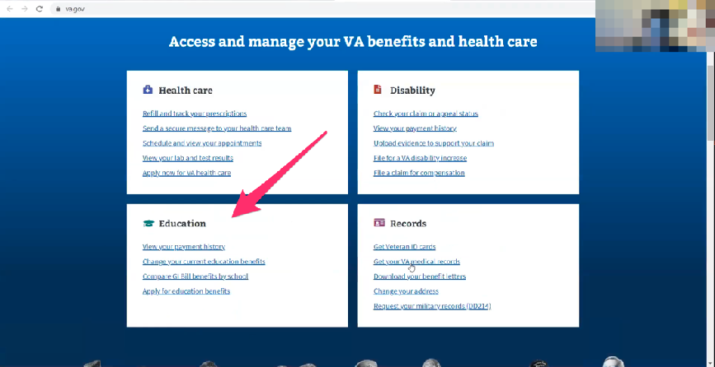

Participant scrolls down [VA.gov](http://VA.gov) home page and mouses over Education block/callout.

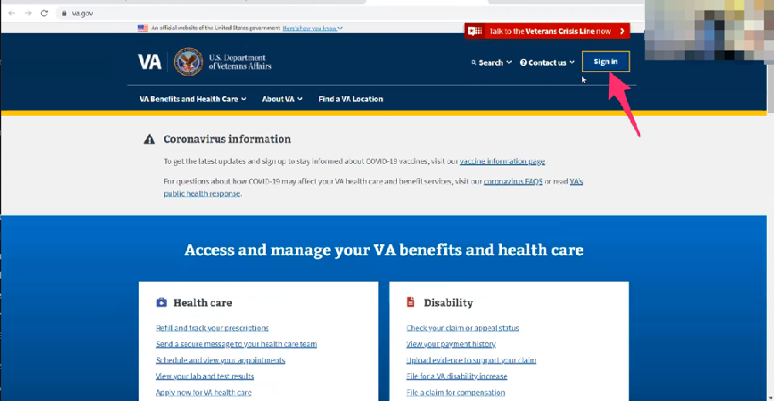

Participant scrolls up [VA.gov](http://VA.gov) and clicks on blue “Sign in” button in upper right of page.

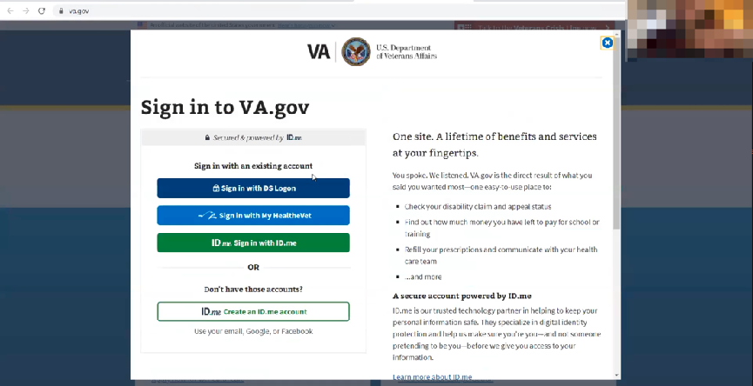

Sign in to [VA.gov](http://VA.gov) modal loads.

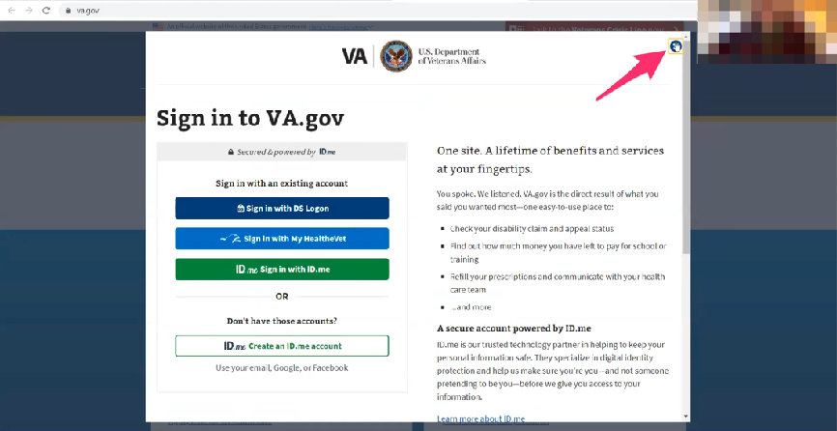

Participant clicks on X in upper right to close modal.

So when I starting figuring out what I needed for my GI bill I went to www.myhealth.va.gov which is he website on this card. *Participant shows card again.*

It went to My HealtheVet.

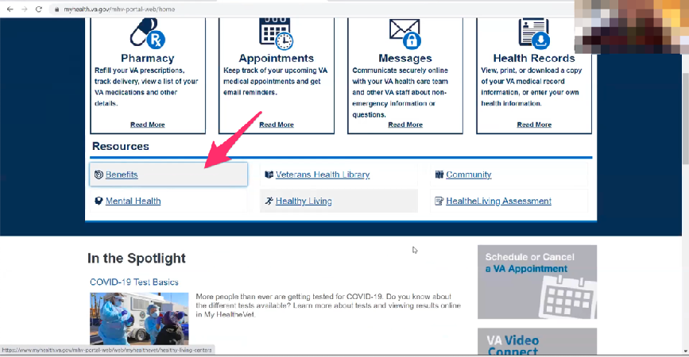

Participant clicks on My HealtheVet website tab that was already open. Didn’t hesitate or try to click back from [VA.gov](http://VA.gov) so noticed the sites were separate tabs

Participant hovers over “Benefits” like under Resources section of home page.

Then when you go to the benefits then it brings you here.

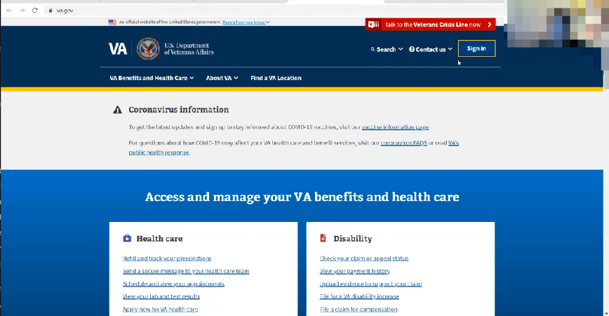

Participant clicks on VA.gov website tab that was already open.

And this is where I started to go in to change the benefits then to apply for benefits.



Participant scrolls down [VA.gov](http://VA.gov) home page and mouses over Education block/callout.

So I researched stuff for the GI bill.

And I had to update my password because it was expired.

**So you found VA.gov through the benefits link on My HealtheVEt:**

Yes.

**Anything else you’ve used on My HealtheVet**:

Not. When he gave me this [My HealtheVet id/info card] I remember using it for my prescriptions but nothing since.

It looks like they have telehealth now.

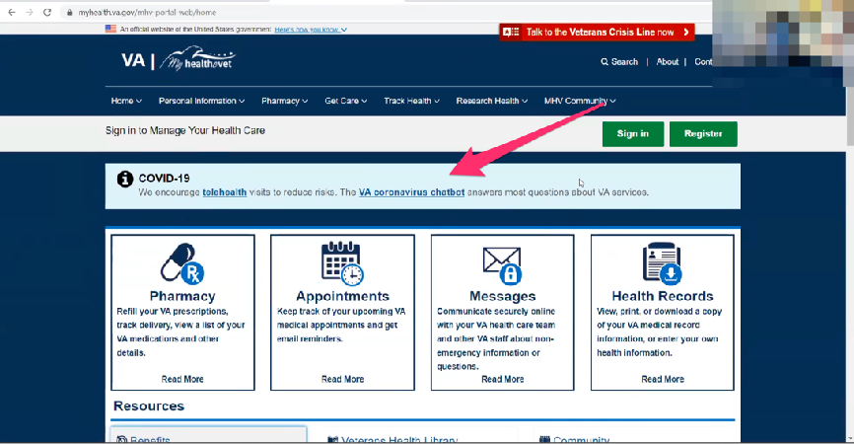

Participant mouses over and reads COVID-19 info box on My HealtheVet home page.

It says COVID-19. They encourage you to use telehealth.

**My HealtheVet patient portal (15 minutes)**

Let's take a look at My HealtheVet together.

Moderator will ask participant to share screen if not already, or show logged in My HealtheVet account. **(5 minutes)**

1. **What do you think you would find the most valuable on this website?**

I don’t now because I don’t use it. But if you can request an appointments and do it on telehealth that is a lot easier than going to the VA.

1. **Under Health Records under these first four boxes. Can you click on Health Records:**

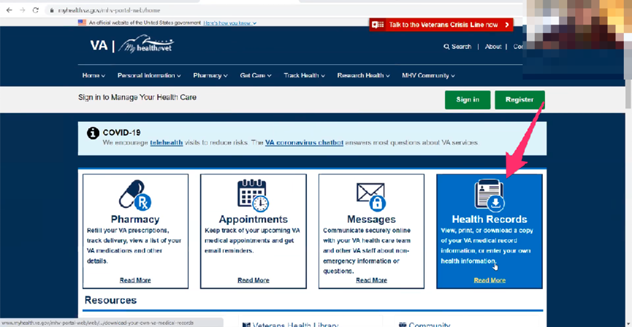

Participant clicks on Health Records box/callout link.

**It might make you sign in. Do you know your log in:**

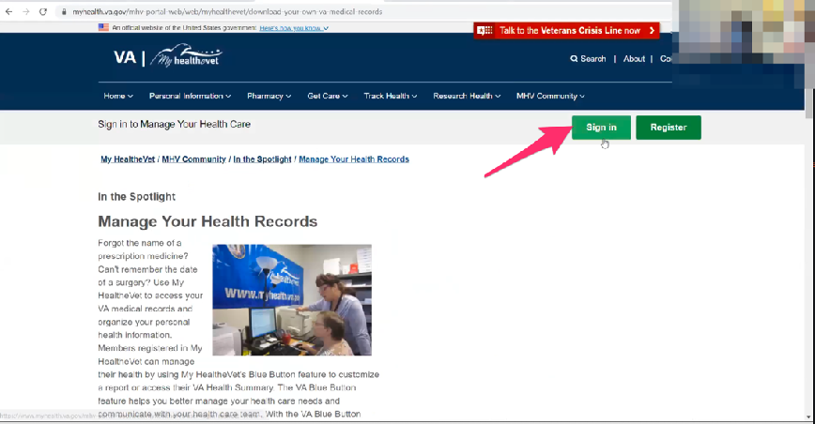

Participant clicks on green “Sign in” button in upper right side of page.

Yeah. So here you can sign in through My HealtheVet.

**Do you know your log in:**

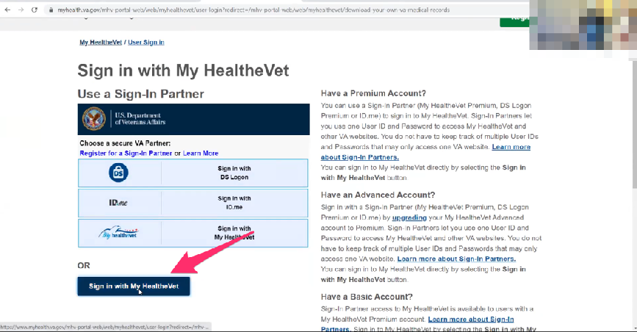

Participant looks through options and then clicks on blue “Sign in with My HealtheVet” button.

That is the only username and password I had when I switched to DC.

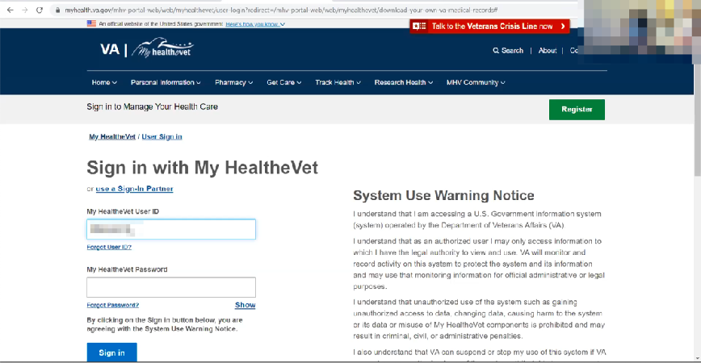

Fills in User Id and Password and clicks blue “Sign in” button.

That is how I went in for the other benefits.

**You’ve been using My HealtheVet for other credentials too:**

Yes.

**Now that you are logged in can you go back home:**

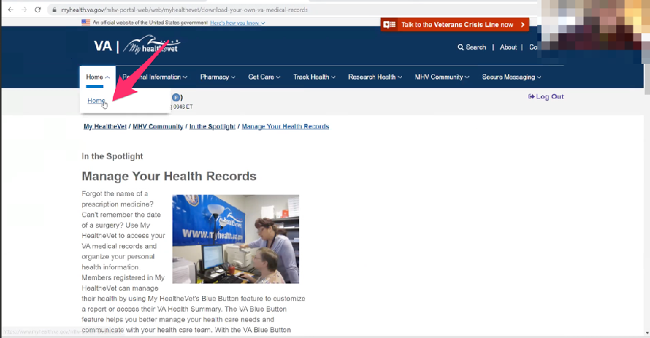

Participant clicks on “Home” in main navigation and then “Home” in the sub menu drop down.

**Under blue button medical report, first impressions and if anything seems useful:**

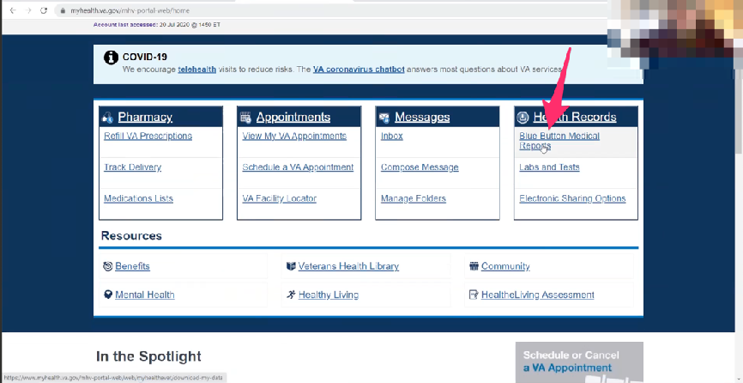

Participant clicks on “Blue Button Medical Reports” under Health Records.

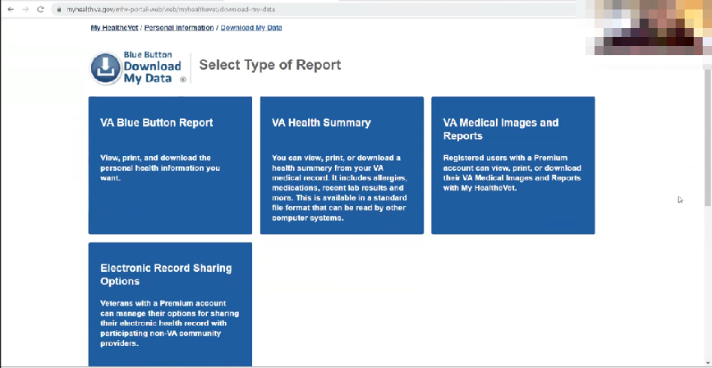

Download My Data page loads. Participants takes several seconds to review it.

It says VA medical images. I wonder if that’s MRI’s and stuff.

*Participant reads to self.*

I don’t know what I would do with it unless I took it to another provider.

*Participant reads to self.*

If I am staying at VA it’s all in the system they would have access. I guess if I were going somewhere else I guess I would have access to my records and imagines.

1. **If you were looking to send your VA health record to an outside provider, which option would you select:**

This says medical images and reports.

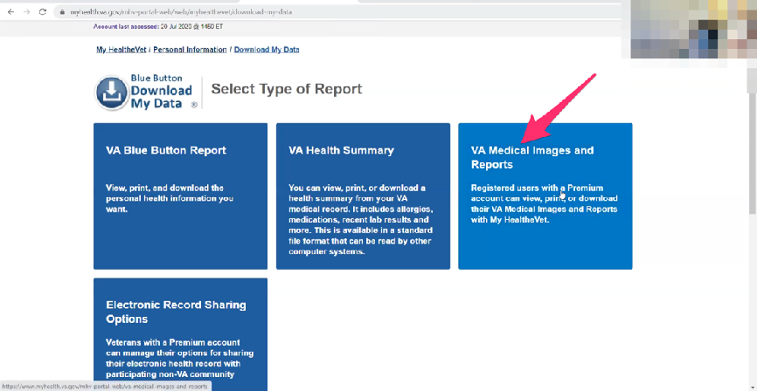

Participant clicks on “VA Medical Images and Reports” box/link.

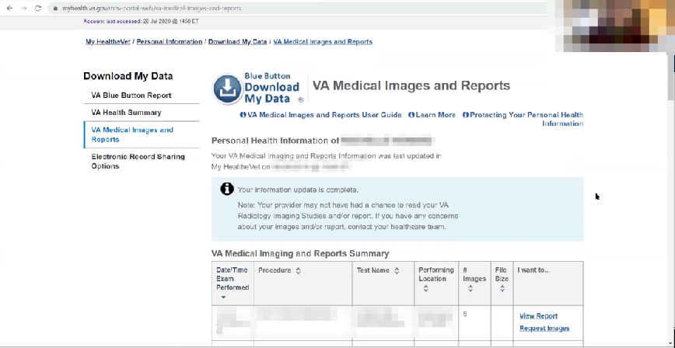

VA Medical Images and Reports page loads. Participant scrolls down page.

This is all of my foot stuff.

Lets look at the images. I’ve never seen these.

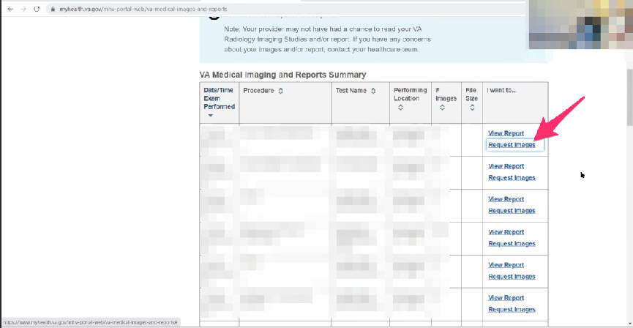

Participant clicks on “Request Images” link for procedure in table.

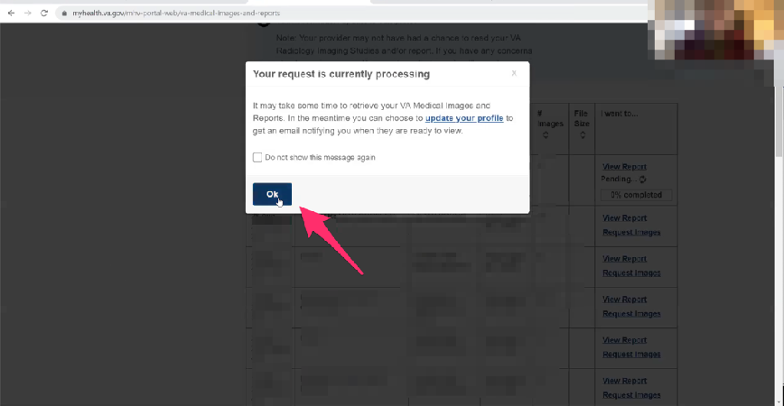

Modal opens with notice that request is processing. Participant immediately clicks blue “Ok” button. Modal closes.

That was when I had it taken out, this is what I was trying to look at.

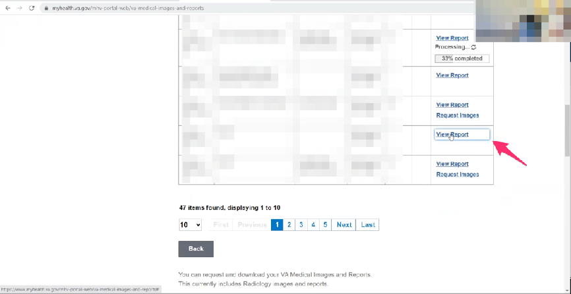

Participant clicks on “View Report” link for another procedure in table.

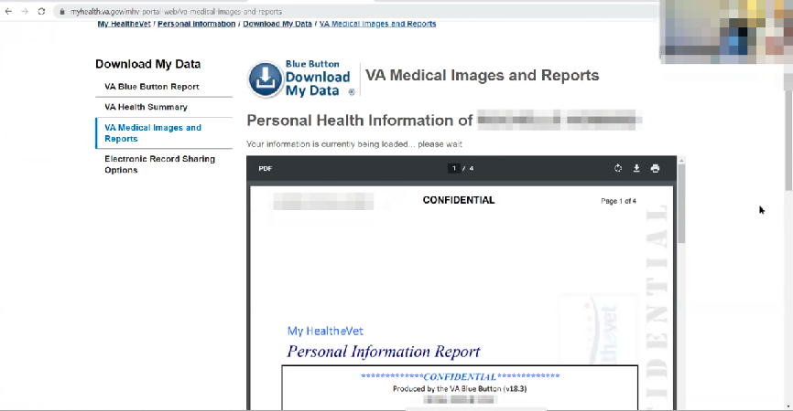

Report page opens. Participant scrolls down and starts reading through PDF report embed.

*Participant keeps scrolling and reading report.*

Who knew.

**Haven’t seen it before:**

No.

**If this were something you could access in real time, would it be useful:**

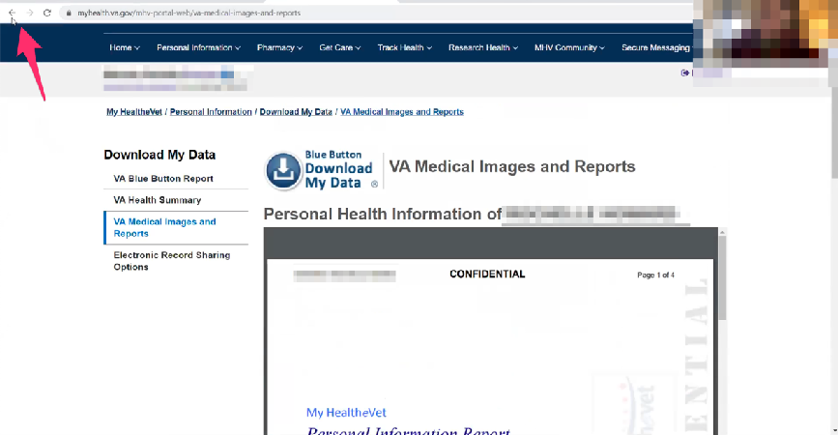

Participant clicks on Chrome back button.

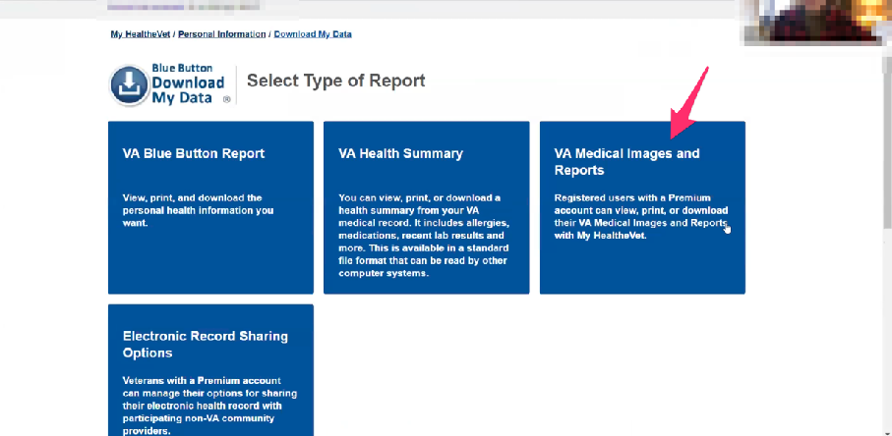

Download My Data page loads. Participant clicks on “VA Medical Images and Reports” box/link again.

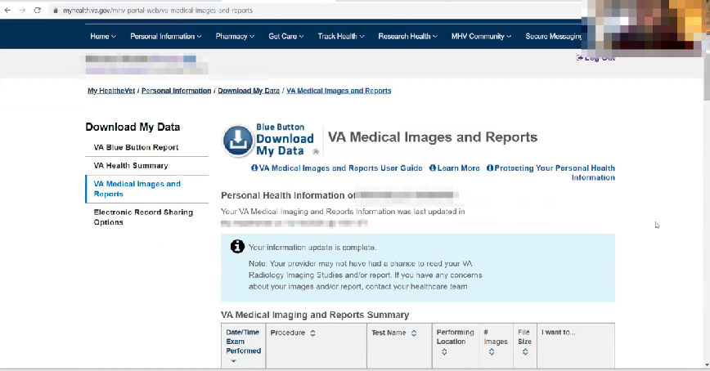

VA Medical Images and Reports page loads.

Even now when you go to a private providers they don’t give you the images or reports. Unless I go into the patient portal. I don’t really go in to look for it unless I need to talk to my doctor about it or take it somewhere.

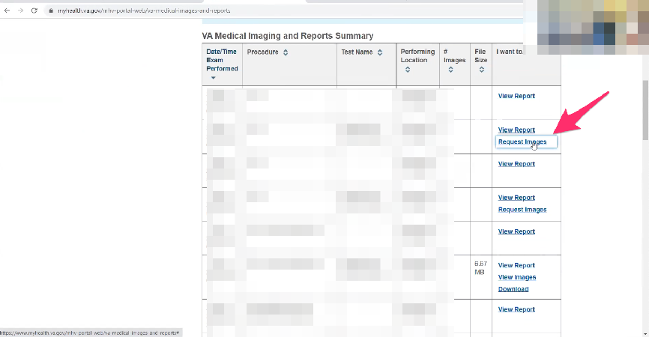

Participant scrolls down page and clicks on “Request Images” link for a procedure in table.



Modal opens with notice that request is processing. Participant immediately clicks blue “Ok” button. Modal closes.

This should have been before or right after they took out the hardware. There was a screw they had to take out. I want to see the image of it, I have never seen it. *Participant laughs.*

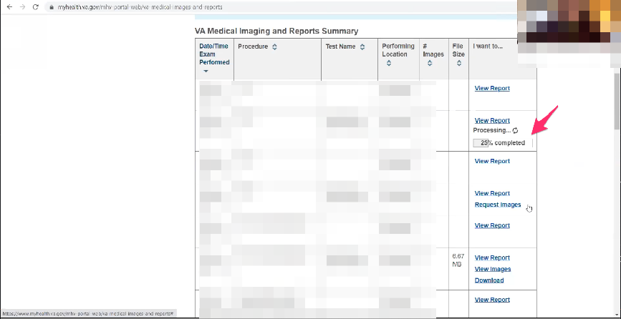

Participant waits. Processing status updates.

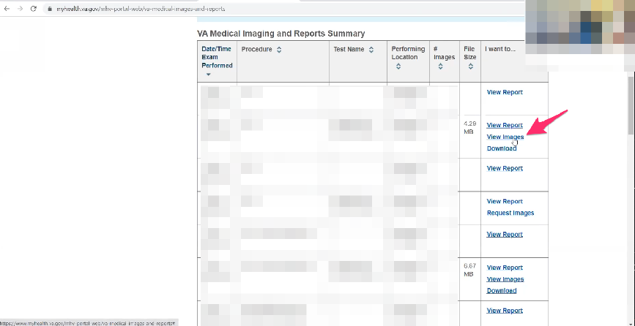

Processing status finishes. Participant clicks on “View Images” link for procedure in table.

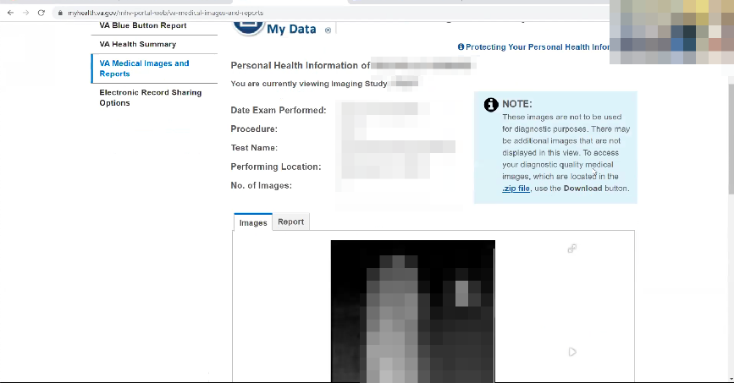

Data page loads. Participant scrolls down to review images.



Participant reviews images.

They aren’t that great. Like right there is the injury.



Participant clicks on gray “Done” button.

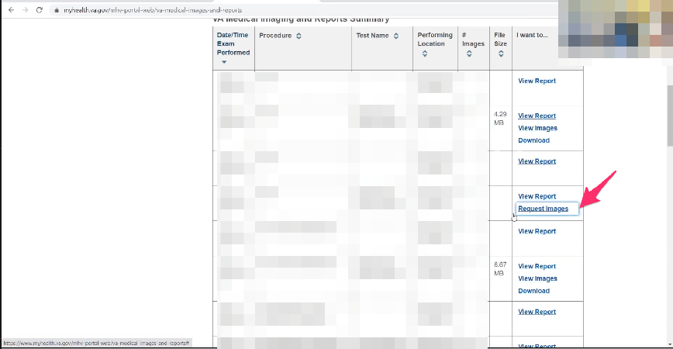

VA Medical Images and Reports page loads with procedure table. Participant clicks on “Request Images” for another procedure.



Modal opens with notice that request is processing. Participant immediately clicks blue “Ok” button. Modal closes.

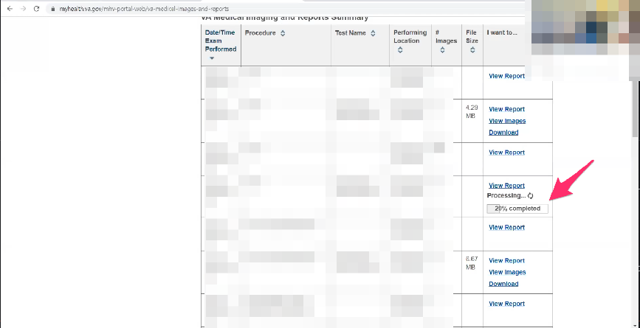

Participant waits. Processing status updates.

1. **In some these there is View Report, View Images, and Download. Do you have any thoughts on the difference on the options:**

If I look at the image and there’s a screw there I want to see what they said about it. *Participant is thinking about the report she is waiting for and not fully considering the question from the Moderator.*

Hopefully it doesn’t take too long.

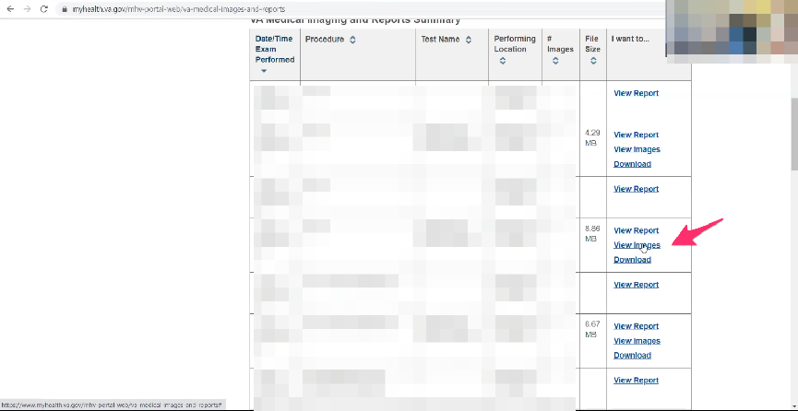

Processing status finishes. Participant clicks on “View Images” link for procedure in table.

I know when they repaired it they needed to put a screw in. there is the screw.

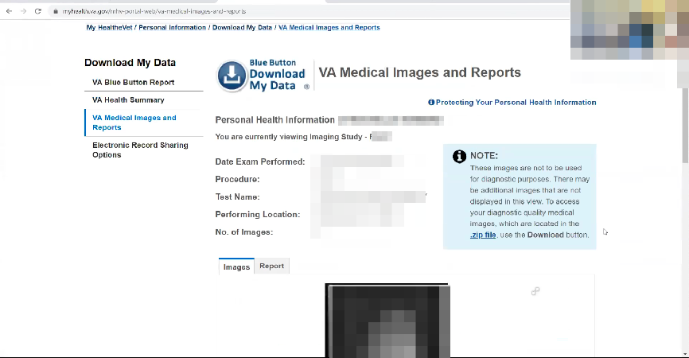

Data page loads. Participant scrolls down to review images.

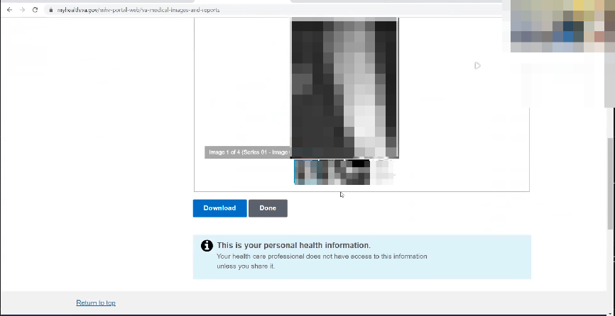

Participant reviews images.

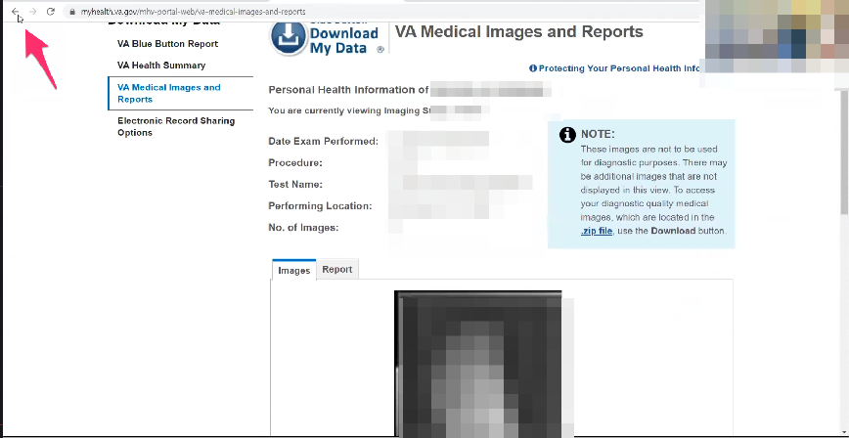

Participant clicks on Chrome back button.

There’s the screw.

Go back.

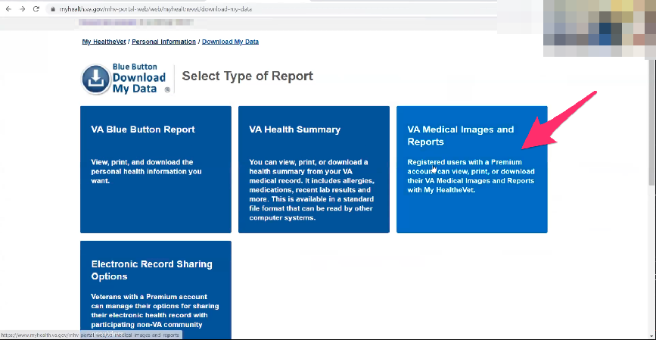

Download My Data page loads. Participant clicks on “VA Medical Images and Reports” box/link again.

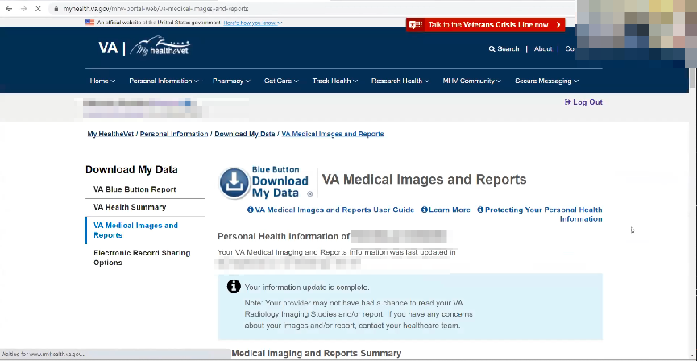

VA Medical Images and Reports page loads.

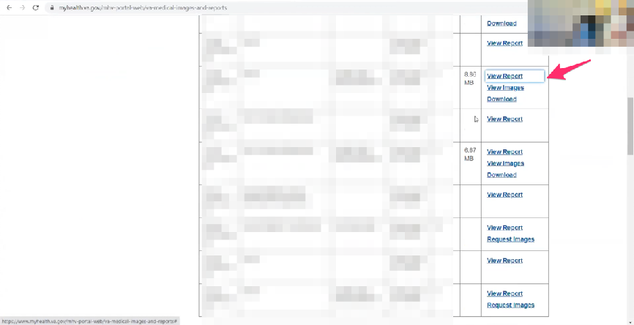

Participant scrolls down page and clicks on “View Report” link for a procedure in table.

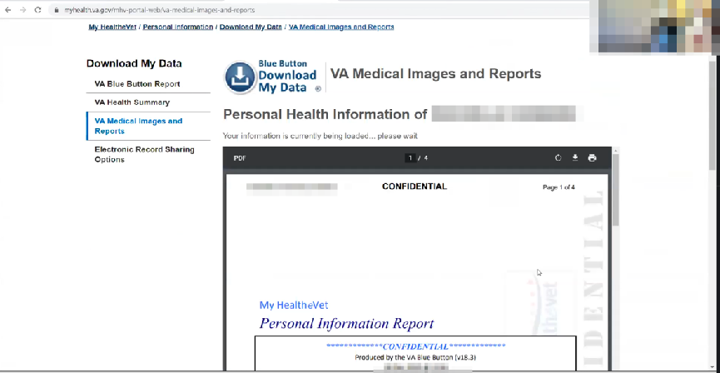

Report page opens. Participant scrolls down and starts reading through PDF report embed.

When was this. This was February 2015

*Participant continues to read PDF and scroll through report.*

September 2016.

1. **What are your thoughts on seeing it from that long ago. Is that something that you would have expected:**

Hmmm.

*Participant continues to read PDF and scroll through report.*

When I first came back from Afghanistan I had issues with my feet. The first issue, I went to the clinic and they started to look into it so they sent me to a podiatrist at the Naval Academy to look at it. This was 2011 and I was probably 33-34 years old. I never had any surgeries before. I never broken anything and they said I have to have surgery and take it out.

I was like that’s it. You are going to put me under and do surgery. I was shocked because I never experienced it before. And then 4 surgeries later. You just trust that is what they are telling you. The first time it was jolting, and then I got used to it with the other two foot surgeries and shoulder surgery.

I remember talking to friends asking that said you just scheduled surgery with a guy you’ve known for 10 minutes. I was like yeah.

At the time you just do what they tell you to do not to have pain.

Looking back at it [medical records], it validates it in some weird way.

**Thank you and closing (2 minutes)**

**Feedback:**

Just try to make it easier for everybody.